Student Name 1:­­­­­­­­­­­­­­­­­­­­­­­­­­­­­_______________________________ Student Number 1:____________

Student Name 2:­­­­­­­­­­­­­­­­­­­­­­­­­­­­­_______________________________ Student Number 2:____________

DEPARTMENT OF ELECTRICAL & COMPUTER ENGINEERING

ENEL 320: Signals & Communications 2020

# DIGITAL COMMUNICATIONS LAB

[Out of 20 marks]

# OBJECTIVES

The aim of this laboratory is to give insight into the performance of digital communications systems and some experience working with the digital signals. In addition, it provides the opportunity to learn more complicated functions in Excel.

##### PREPARATION

**Before you come to the laboratory**, read through your lecture notes on sampling, quantisation, PCM, and Fast Fourier Transforms. You should also do the Fourier derivations required (see laboratory notes in this handout). Additional information can be found in the textbooks. Then, carefully examine the Excel spreadsheet program Digital Comms lab.xls available on Learn.

##### WHY EXCEL?

Matlab is a very powerful program. But it is also very expensive and therefore, is not widely available in industry. Most engineers will not use Matlab (or similar programs) in their jobs, but instead use Excel to do all calculations required. This does not necessarily make it the best tool for the job – but it is often the only one you will have! Remember that as with any programme, a spreadsheet should be easy for others to use and understand. Use variables. Label things. Use colours, headings, cell borders etc. so that another engineer or a client can use the spreadsheet and/or can understand a pdf version.

As with Matlab, Excel cannot process analogue signals. Therefore, the x(t) in the workbook is still a list of values, but they are close enough together that it is a good substitute for an analogue signal in the time domain.

Note that this lab does not require the use of macros.

1. **TRANSMITTER**

$$x_{PCM}[n]$$

$$x_{Q}[n]$$

$$x[n]$$

$$x(t)$$

Encoder

Quantiser

Sampler

*Figure 1: Transmitter Configuration*

Principle: An analogue signal, $x\left(t\right)$, is sampled to create a discrete time signal, $x[n]$. This signal is then quantised to create the digital signal, $x_{Q}[n]$. Finally, the digital signal is encoded into a string of binary bits using pulse code modulation (PCM) and is transmitted.

**PLEASE COPY ALL FIGURES INTO THIS DOCUMENT DIRECTLY.**

#### PROCEDURE

1. **Derive and sketch (by hand) the Fourier Transform, $X(ω)$, of the message signal, $x(t)$, shown in Figure 1,** for the specific case where the message is $x\left(t\right)=10\cos^{2}\left(50πt\right)+2cos⁡(50πt)$. [See lecture notes for help, e.g. LN3.]
2. **From the answer for Q1, what is the minimum sampling rate (in rad/s) you should use in your computer simulation of the system? What sampling period corresponds to this sampling rate?**
3. **From your answers for Q1 and Q2, sketch (by hand) X(Ω) between -3π and 3π.** [See lecture notes for help, e.g. LN10.]
4. A copy of the Excel spreadsheet “Digital Comms Lab” is available on Learn. This will be the basis for the rest of this lab report. The blue boxes are inputs/variables. The purple boxes are to be filled in with formulae. You can add additional columns/tables to the spreadsheet if you want to.

Using formulae, fill in the purple boxes in column C of the “Nyquist Rate – Tx” worksheet. Cell C6 (Period) is done for you as an example. Using cells C2 to C9 (you may not need all of them), fill in column D and calculate the first 256 samples of x[n] (column F). **Using values of x[n] generated in the excel spreadsheet, derive and sketch (by hand) the Discrete Fourier Transform, $X[k]$, of the message signal, $x(t)$**. **The sketch should show from k = -4 to k = 4**.

1. If there isn’t a Data Analysis icon under the Data tab, install the Analysis ToolPak as per the following instructions. This will enable you to do an FFT without manual calculations. Go File -> Options. Select Add-Ins from the lefthand list. At the bottom of the Add-Ins box select Manage: Excel Add-Ins, and press the ‘Go’ button. Tick the box next to Analysis ToolPak. Press ‘OK’. In the Data tab there should now be a Data Analysis icon.

**Create a new table for the Fourier transform. Using the FFT algorithm, calculate X[k] from the sampled signal. Calculate the magnitude and phase of X[k]. Ensure the table is well-formatted (e.g. headings, borders, font types), and easy to understand when as presented as a picture/pdf (e.g. to a client). Paste the table in below as a picture.**

1. The sampled signal is quantised using a 4 bit quantiser with a dynamic range of 20.A figure showing the first 0.1s of the original signal, x(t), is given. **On a separate figure, graph both the sampled signal, x[n], and the quantised signal, xQ[n]. Graph the number of samples that corresponds to 0 to 0.1s. Copy and paste the new figure under the x(t) figure.** Choose an appropriate type of graph for the sampled signals, and ensure it is well-formatted and labelled. **What is the maximum quantisation error you have?**

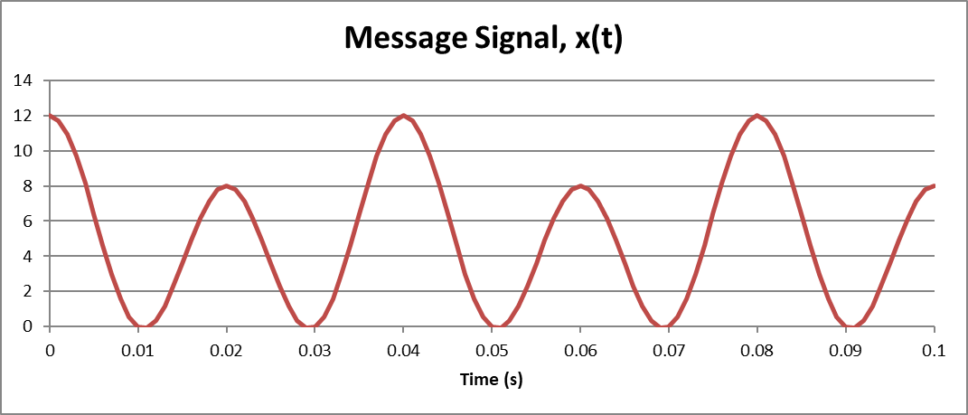



1. Calculate the quantisation error of the quantised signal for the first 256 samples. **Graph the quantisation error for the same number of samples as used in Q6. Copy and paste the figure below. What is one change you could make to the quantiser to reduce the errors?**
2. **Calculate the quantisation signal to noise ratio – what is it?**
3. Encode your quantised signal using 4-bit PCM. You do not have to use the “Quantisation Level” column if you don’t want to. You now have a signal that is ready for transmission. **What are the first ten samples encoded as (in bits)?**
4. **Use the “Above Nyquist Rate – Tx” worksheet to see what happens when a higher sampling rate is used. Does the maximum quantisation error in the quantised signal change? If so, in what way, and why? What is the maximum possible quantisation error? What is the advantage of sampling at more than the Nyquist rate (comment on both the time and frequency domains)?**
5. **RECEIVER**

Interpolater

Decoder

$${\hat{x}}_{PCM}[n]$$

Noise Removal

$$x_{PCM}\left[n\right]+noise$$

$$\hat{x}(t)$$

$${\hat{x}}_{Q}[n]$$

*Figure 2: Receiver Configuration*

Principle: During transmission channel noise will be added to the PCM signal. The receiver needs to remove this noise, decode the PCM bitstream, and then reconstruct the analogue signal.

#### PROCEDURE

1. On the “Rx” tab of the Excel spreadsheet “Digital Comms Lab” a random number generator has been set up to mimic the addition of noise. The formula to divide the bitstream into one bit per cell is also provided, and columns B, C, E, F, N, and O should be automatically populated based on your answers from Part A. Two tables are provided – one for low levels of noise, and one for high levels of noise. With low noise set to 0.2, and high noise set to 0.7, try to recover the original signal. The columns provided do not need to be used, and you can amend them as you wish. Note that the random number generator changes every time anything is recalculated, so your results will keep changing. **Use the** **show formulas button in the forumulas tab and copy and paste in a picture of the columns/formulae that you used to get a recovered signal (this would be columns G to L if you didn’t change anything).**
2. **Create a table that shows the samples of recovered signal from 0 to 0.1s for both low and high noise cases. Copy and paste the table below.**
3. **Using first-order interpolation to reconstruct the analogue signals, create two figures that show 0 to 0.1s of the recovered signal. One for the low noise case, and one for the high noise case. Copy and paste the figures below.**
4. The “RX – Higher Frequency” tab adds noise in a somewhat more realistic way (although still not very realistic). Recover the bit stream using the same methodology as in the “RX” tab. **What has happened to the recovered signal due to the change in noise characteristic? What could you add to the receiver to remove this noise?** Hint: think about what is happening in the frequency domain.